Bijlage: Format voor weekplanning

Kleur onderstaande weekindeling in om overzicht te krijgen in jouw tijdsbesteding.

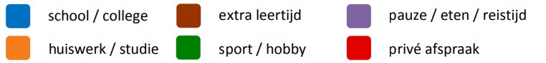

|  |  |  |  |  |  |  |  |
| --- | --- | --- | --- | --- | --- | --- | --- |
| **Tijd** | **Ma** | **Di** | **Woe** | **Do** | **Vrij** | **Za** | **Zo** |
| 7:00 |  |  |  |  |  |  |  |
| 7:30 |  |  |  |  |  |  |  |
| 8:00 |  |  |  |  |  |  |  |
| 8:30 |  |  |  |  |  |  |  |
| 9:00 |  |  |  |  |  |  |  |
| 9:30 |  |  |  |  |  |  |  |
| 10:00 |  |  |  |  |  |  |  |
| 10:30 |  |  |  |  |  |  |  |
| 11:00 |  |  |  |  |  |  |  |
| 11:30 |  |  |  |  |  |  |  |
| 12:00 |  |  |  |  |  |  |  |
| 12:30 |  |  |  |  |  |  |  |
| 13:00 |  |  |  |  |  |  |  |
| 13:30 |  |  |  |  |  |  |  |
| 14:00 |  |  |  |  |  |  |  |
| 14:30 |  |  |  |  |  |  |  |
| 15:00 |  |  |  |  |  |  |  |
| 15:30 |  |  |  |  |  |  |  |
| 16:00 |  |  |  |  |  |  |  |
| 16:30 |  |  |  |  |  |  |  |
| 17:00 |  |  |  |  |  |  |  |
| 17:30 |  |  |  |  |  |  |  |
| 18:00 |  |  |  |  |  |  |  |
| 18:30 |  |  |  |  |  |  |  |
| 19:00 |  |  |  |  |  |  |  |
| 19:30 |  |  |  |  |  |  |  |
| 20:00 |  |  |  |  |  |  |  |
| 20:30 |  |  |  |  |  |  |  |
| 21:00 |  |  |  |  |  |  |  |
| 21:30 |  |  |  |  |  |  |  |
| 22:00 |  |  |  |  |  |  |  |
| 22:30 |  |  |  |  |  |  |  |
| 23:00 |  |  |  |  |  |  |  |